All figures

Initial Process Model

**System Definition**

Acceptance Testing

Needs Assessment

Requirements

Extra Functional Properties

Hardware Sourcing

**System Development**

Architecture Design Refinement

Acceptance Testing

Integration Testing

Embedded System Design

Component Testing

Component Design

Development

**System Deployment**

Product Creation

Implementation

Acceptance

Final Process Model

**Figure 9.1 – Final Process Model**

**System Definition**

Acceptance Testing

Needs Assessment

Requirements

Extra Functional Properties

Hardware Estimation

**System Development**

Architecture Design Refinement

Acceptance Testing

Integration Testing

Embedded System Design

Unit and Component Testing

Component Design

Development/Prototyping

**System Deployment**

Product Creation

Implementation

Acceptance

#### **Figure 3.1: Context Diagram**

Motion Ball HW

Record Data

Request data collection or display

Display data in user requested form

User

**Figure 3.2 Logical Data Model**

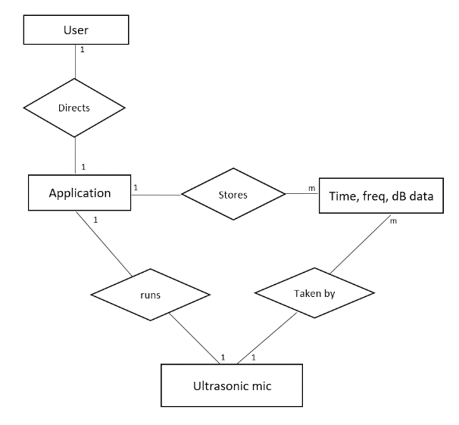

Acceleration and time data.

MBHW

MBA

**Figure 3.2- State Transition Diagram.**

Return to base screens

Standby

User requests Data Table View

User requests data collection

Table View

Cancelled

Accepted

Invalid Request

User ends Table View

Application begins accepting data from the accelerometer

Running and Graphing

MBHW unresponsive or collection error

**Figure 4.2 – Component and Connector Plus Allocation View**

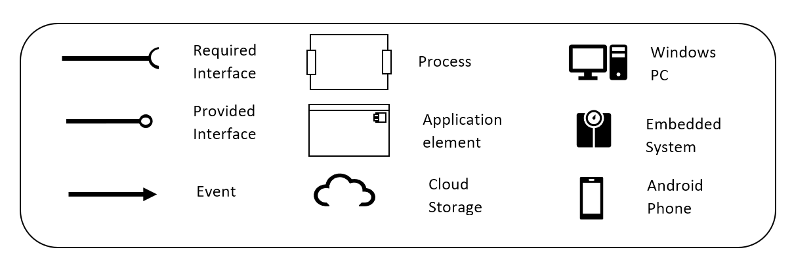

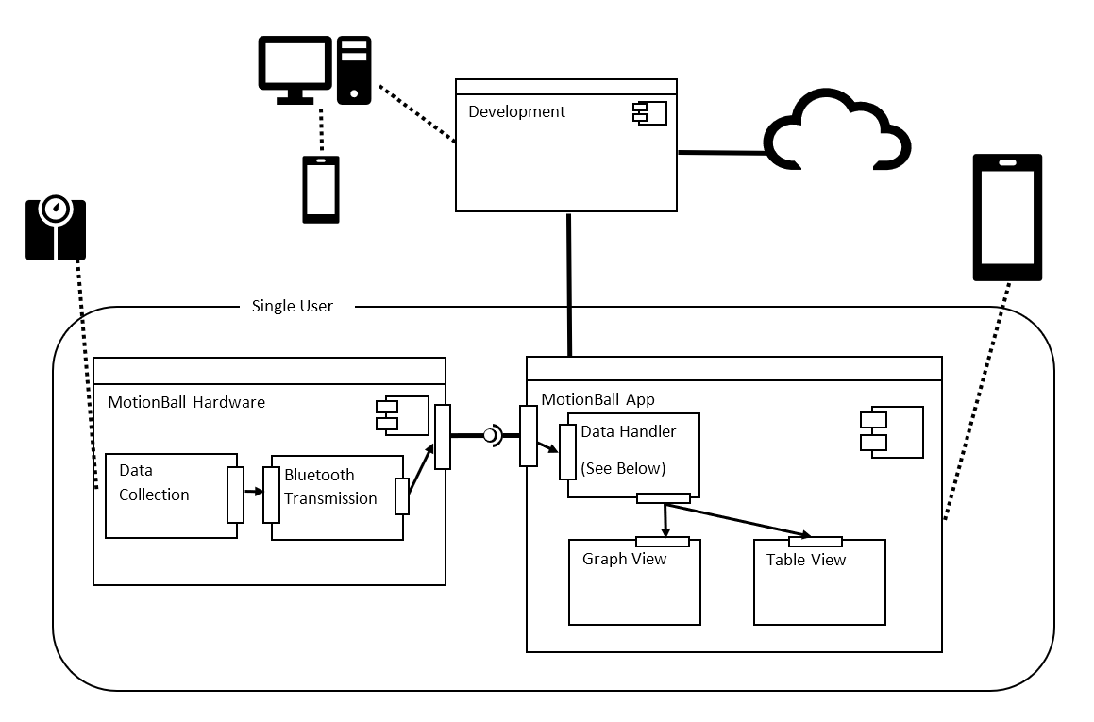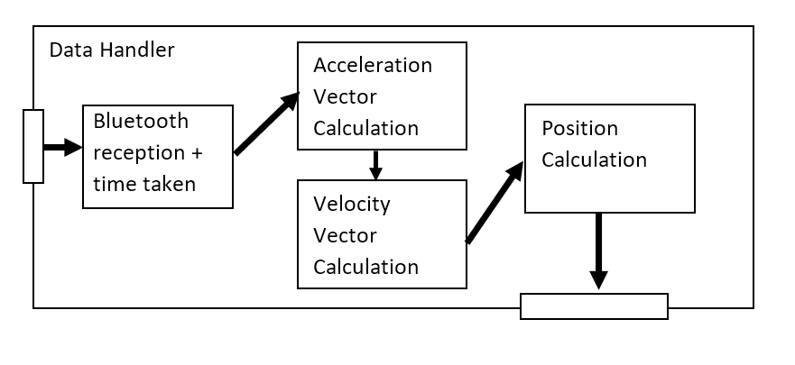

Data Collection completes

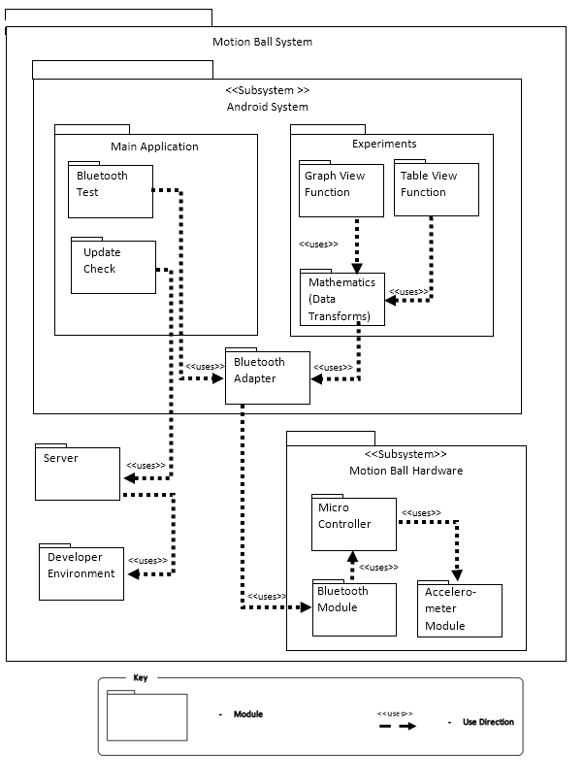**Figure 4.1- Decomposition and Uses View**

### **Figure 4.3 – Circuit Diagram**

Prototype

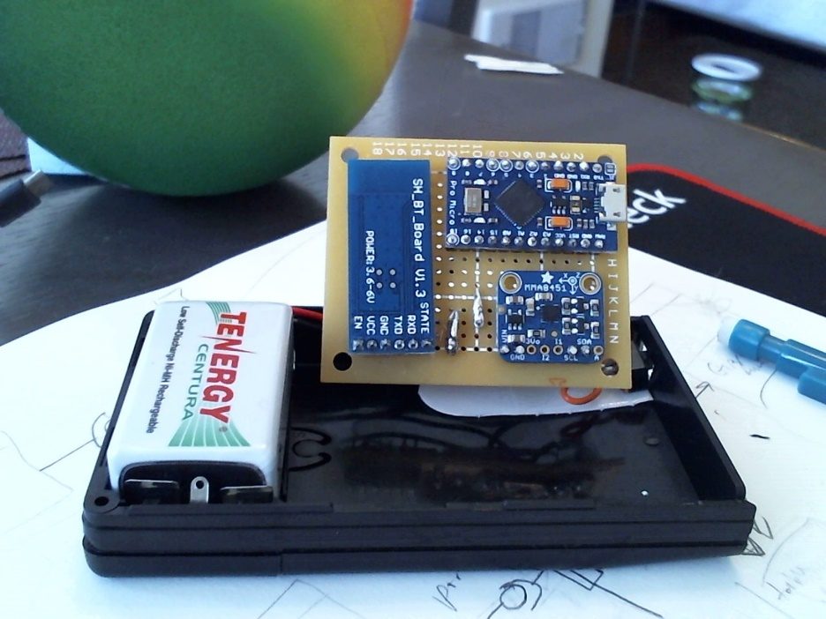

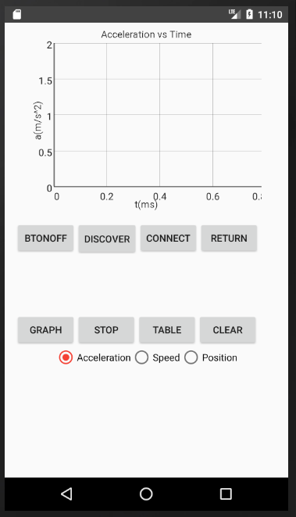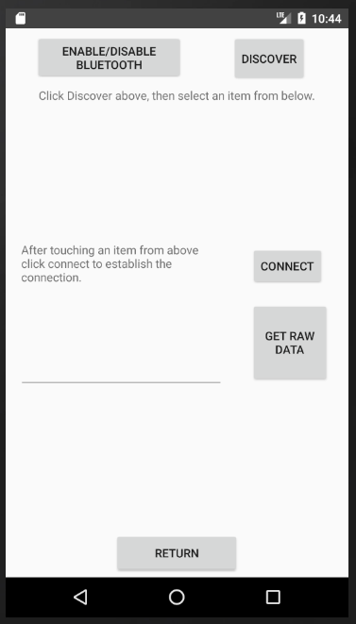App Screens

